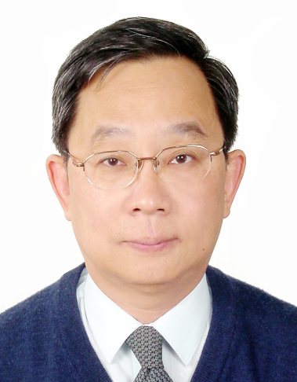

Dr. Chin-Hsiung Loh
Professor
Department of Civil Engineering

National Taiwan University

Taipei 10617, Taiwan
e-mail: lohc0220@ccms.ntu.edu.tw

Dr. Chin-Hsiung Loh is a professor in the Department of Civil Engineering at the National Taiwan University. He is also a distinguished professor at the National Taiwan University. He received his Ph.D. degree in Civil Engineering from the National Taiwan University. He had been Research Associates at UC Berkeley and University of Illinois at Urbana. He had also been a visiting scholar at Stanford University and California Institute of Technology, respectively, and a visiting professor at the University of Michigan. He was the Director of National Center for Research on Earthquake Engineering, Taiwan, during 1997-2003, and the Director of National Center for Disaster Reduction in 2003. He also served as a program director of earthquake hazard mitigation program of NSC during 2005-2008. Dr. Loh research interests include structural system identification and damage detection, structural health monitoring, structural control and earthquake hazard mitigation. Dr. Loh received NSC outstanding research award from 1993 to 1997, and NSC special research award from 1997 to 2003. Dr. Loh was recently awarded the distinguished professor from National Taiwan University in 2006.
Instructions for Preparing One-Page Position Paper for US-Taiwan MC/MD Workshop
Chin-Hsiung Loh
The length of the position paper should not exceed 1 page inclusive of figures, tables, and photographs. The position paper should be formatted for A4 paper with 2.5cm margins on all four sides. Use a 12 point all caps Times Roman font centered for the title of the paper, and an 11 point Times Roman font either justified or left flushed for the text, and a 10 point Times Roman font for the author affiliation footnote. The paper text should be typed single spaced. The position paper for the US-Taiwan MC/MD Workshop will be prepared in hardcopies and distributed during the workshop. Please visit our MC/MD Workshop website (http://conf.ncree.org.tw/IndexEng.aspx?n=I09905060) and submit your position paper online before April 26, 2010.

Professor, Department of Civil Engineering, National Taiwan University, Taipei, Taiwan

